Doing and living medical anthropology: Personal reflections can be ordered (printing on demand) from the publisher: bvdcamp@xs4all.nl

Price € 25.00 (postage not included). ISBN 97890 79700 25 7

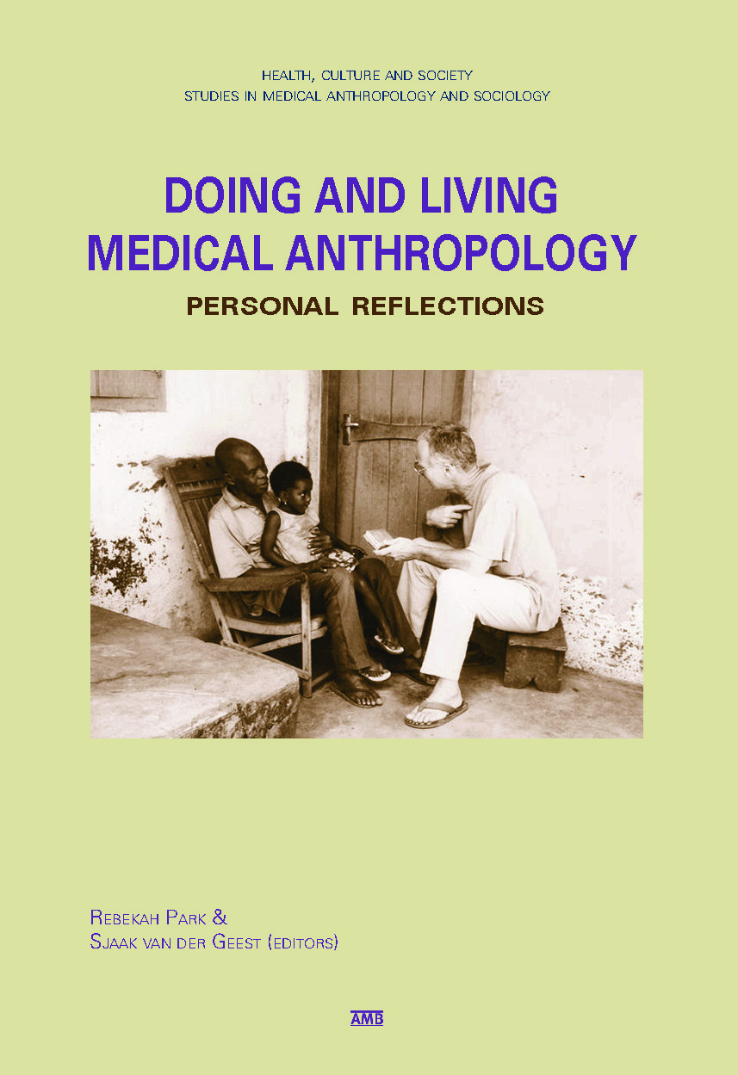

The essays in Doing and Living Medical Anthropology: Personal Reflections consider what medical anthropology means in the academy and outside of it. Written by a diverse group of anthropologists, some of whom also work as doctors, public health workers, and NGO staff members, the essays share personal insights on how they used anthropology to solve health problems and improve interventions.
Several of the contributors draw on their own illness experiences to reconsider the health challenges they have previously sought to understand, analyse, and document. Other essays come from authors who have struggled to incorporate anthropological methodologies and perspectives in multi-disciplinary research and medical relief work. Also included are essays from professional anthropologists who reflect on the value of their discipline's mission and methodology. This collection demonstrates how anthropology is used in policy and health interventions and attempts to bridge the gaps between policymakers, clinicians, NGO workers, doctors, and academic researchers.
The book was published in the "Health, Culture & Society" series of the division Medical Anthropology and Sociology of the University of Amsterdam. Diemen: AMB Publishing. 156 pp. ISBN 97890 79700 25 7.

